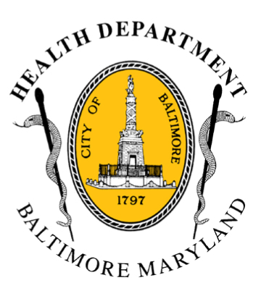
BCHD PRESS RELEASE
Baltimore City Health Department
1001 E. Fayette Street • Baltimore, Maryland 21202
Stephanie Rawlings-Blake, Mayor
Leana Wen, M.D., Commissioner of Health

FOR IMMEDIATE RELEASE

Media Contact: Michael Schwartzberg, PIO
O: (443) 984-2623 C: (443) 462-7939 E: michael.schwartzberg@baltimorecity.gov
Health Commissioner Extends Code Blue In Baltimore
Through Friday

BALTIMORE, MD (February 16, 2015) - With forecasts calling for four to eight inches of snow from Monday evening to midday Tuesday, and temperatures and wind chills predicted to be below zero during the rest of the week, Baltimore City Health Commissioner Leana Wen, M.D. has ordered the Code Blue extended through Friday, February 20. An extended Code Blue advisory had previously been in place from February 12 – 16.

This is the seventh Code Blue alert for Baltimore this winter, and the city has experienced six cold weather related deaths.

“This week we will experience some of the coldest weather Baltimore has had in recent years,” Dr. Wen said. “We all have to take this very seriously. Extreme cold can permanently injure or even kill. This is the time to care for your neighbors—those who are the most vulnerable are the elderly, children, people with chronic medical conditions, and homeless individuals.”

Alcohol use has been a contributing factor in at least three of the city’s cold-weather deaths this year, and Dr. Wen reminds Baltimoreans that alcohol and cold temperatures do not mix. “Alcohol blunts a person’s natural response to hypothermia, preventing their mind from recognizing they are too cold and one’s body from naturally shivering to keep warm.”

The Health Commissioner may declare a Code Blue alert when temperatures, including wind chill, are expected to be 13˚F or below or when other conditions are severe enough to present a substantial threat to the life or health of vulnerable Baltimore citizens. Code Blue indicates an increased risk for cold injuries or even death for those exposed to low temperatures.

During a Code Blue, public and private shelters are available with extended services and assistance is available for those with no heat or electricity. The Mayor’s Office of Human Services will operate a 24-hour Housing & Resource Center for men and women at 620 Fallsway with 60 additional spaces available for residents seeking meals and sleeping quarters. In addition, all of Baltimore City's 13 senior centers will have free emergency meals available for clients.
- more-
2-2-2
Cold Weather Stats For Baltimore
Winter Season | Code Blue Days Declared | Hypothermia-Related Deaths
2014-15 | 20 | 6
2013-14 | 34 | 4
2012-13 | 10 | 5
2011-12 | 11 | 3
- 2014-15 stats are season to date and include the February 17-20 declaration.

Cold Weather Tips for Staying Healthy:
- Wear multiple layers of loose-fitting clothing.
- Always wear a head covering, like a hat and/or scarf, when outdoors.
- Drink plenty of fluids and avoid alcoholic beverages.
- Protect yourself against falls in icy or snowy conditions
- Check on those who are children, the elderly and/or chronically ill.
- Provide appropriate shelter for domestic animals.

Other Tips For Keeping Safe in Cold Weather:
- Keep space heaters and candles away from flammable materials, such as curtains, furniture and loose clothing.
- Check your carbon monoxide detector and make sure it’s working.
- Do not use prohibited heat or power sources, such as stoves or generators. They may cause fire or carbon monoxide poisoning.
- Do not leave your car running in a closed space such as a garage.

Residents are encouraged to contact 311 if a neighbor is without heat or power so that city agencies can assist them. Energy assistance may be available to those who need it. For more information, individuals may contact one of the regional Community Action Partnership centers in Baltimore or call the Office of Home Energy Programs at 410-396-5555. Additional cold-weather resources for the public including a listing of city and private shelters, is available on the Health Department’s website (http://health.baltimorecity.gov/). For other cold-related inquiries and service requests, or to find a nearby homeless shelter, residents can call 211.

###

